17.106: The mass of the steam condensed 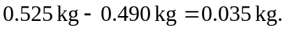The heat lost by the steam as it condenses and cools is
and the heat gained by the original water and calorimeter is
Setting the heat lost equal to the heat gained and solving for 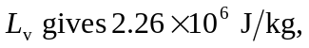or
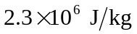 to two figures (the mass of steam condensed is known to only two figures).

